**Skills Log**

**Step 1:** Choose Skills Log Activity Type

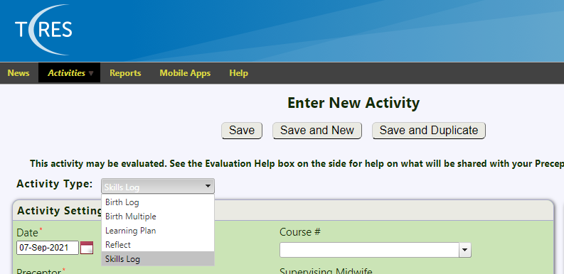

**Step 2:** Activity Settings

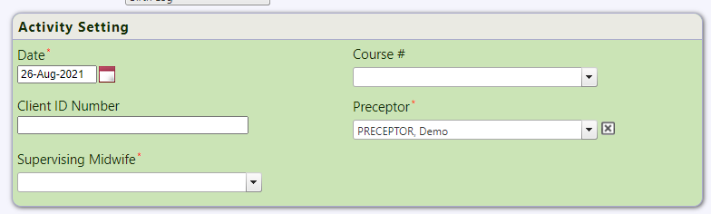

**Date:** Enter the date of the **Birth** not the date when the activity is being created in T-Res.

**Course #:** Select your course from the drop-down menu.

**Preceptor:** Select your Preceptors name from the drop-down menu or type the first few letters of their name to auto fill.

**Midwife:** Choose the Midwife that attended the birth with you.

**Step 3:** Activity Detail

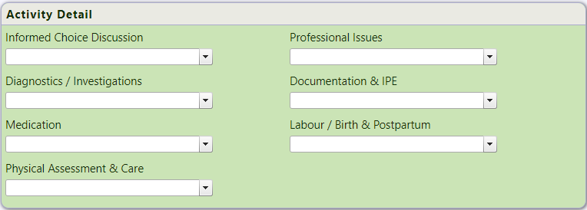

All fields are multi-pick list items to gather activity details.

**Step 4:** Other Notes

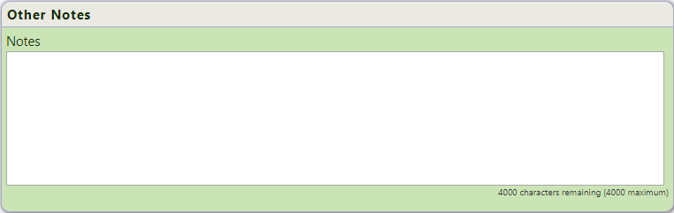

Any Comments that you would like to add about the Skills Log Activity, these will be read be visible by your Preceptor.

**Step 5:** Verification



When the activity is completed, enable the “Ready for Evaluation” checkbox in order for it to be sent to your Preceptor for Review. The Activity will not be created as an evaluation until this box is enabled.

**Step 6:** Other Information

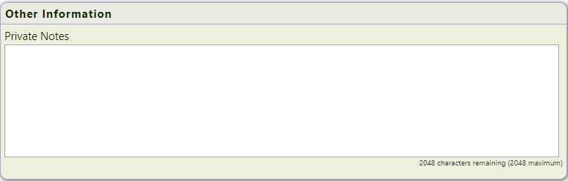

Private Notes section that can only be viewed within your account, these comments are for your eyes only.