**Birth Log**

Creating an Activity: Birth Log

**Step 1:** Choose Birth Log or Birth Multiple activity type

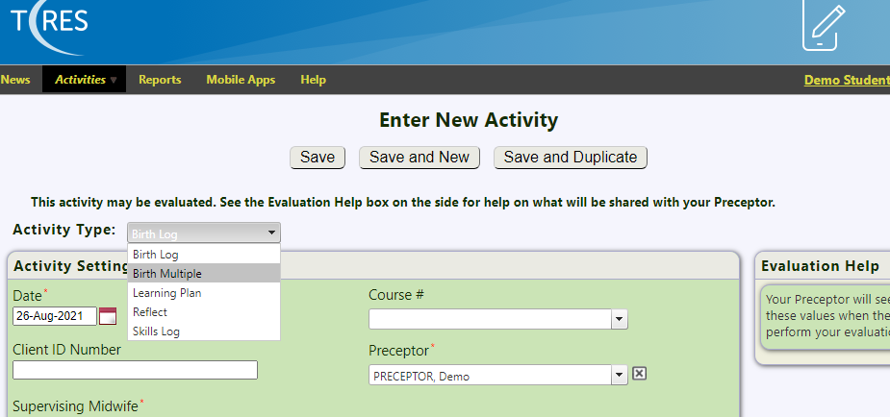

**Step 2:** Activity Settings

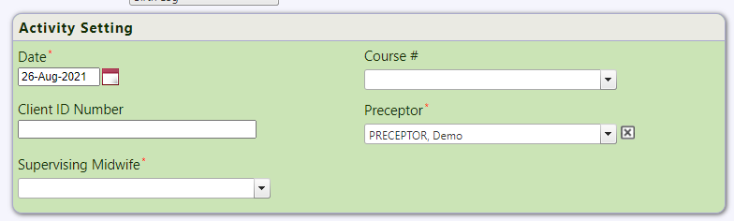

**Date:** Enter the date of the **Birth** not the date when the activity is being created in T-Res.

**Course #:** Select your course from the drop-down menu.

**Client ID Number:** To protect client confidentiality you **must** use a code system. Please refer to your instructor for guidance.

**Preceptor:** Select your Preceptors name from the drop-down menu or type the first few letters of their name to auto fill.

**Midwife:** Choose the Midwife that attended the birth with you.

**Step 3:** Activity Detail

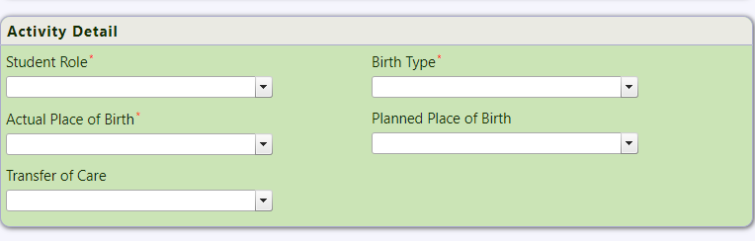

All fields are single pick list items to gather activity details.

**Step 4:** Mother Details

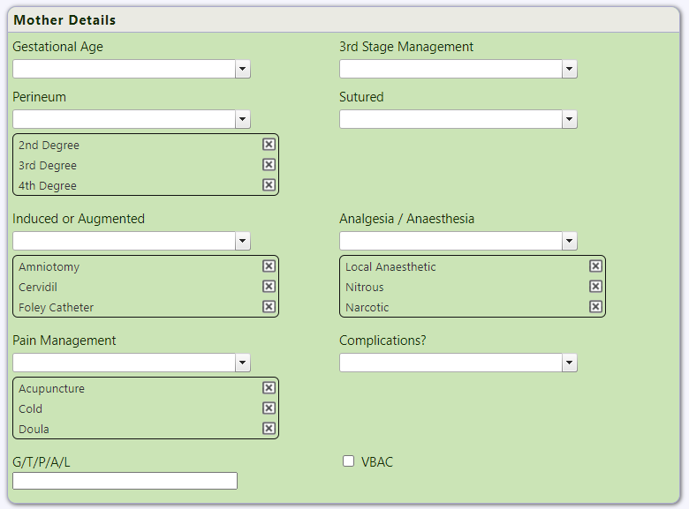

Mixture of multi-item pick lists, single item pick lists, text boxes and checkboxes (flags).

**Step 5:** Baby Details

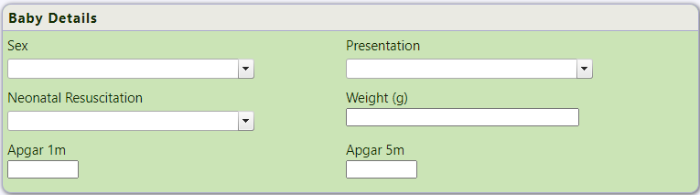

Mixture of Single Pick-list items and text boxes.

**Step 6:** Visit Details

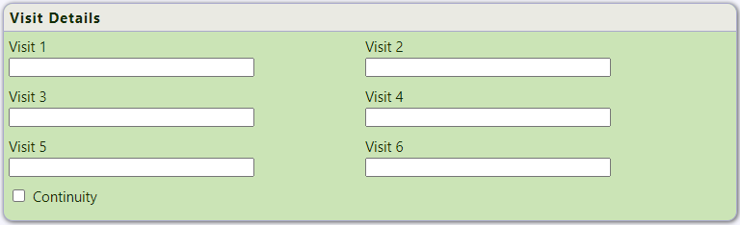

Mixture of text boxes as well as a checkbox (flag) at the bottom.

**Step 7:** Other Notes

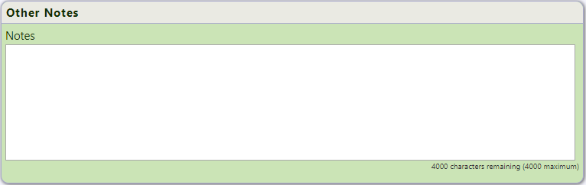

Any additional Notes for Birth

**Step 8:** Verification



Must be enabled in order to create an Evaluation that will be reviewed by your Preceptor and Tutor.

**Step 9:** Other Information

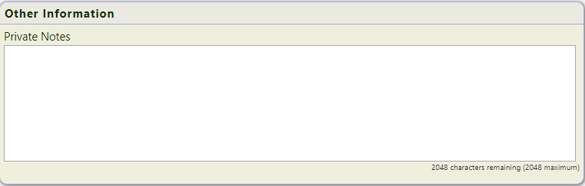

Private Notes section can only be viewed from your account, any information entered is for your eyes only.