**Midterms/Final**

Creating an Activity: Midterm and Final forms

**Step 1:** Choose a Midterm or Final from the Activity Type drop-down list

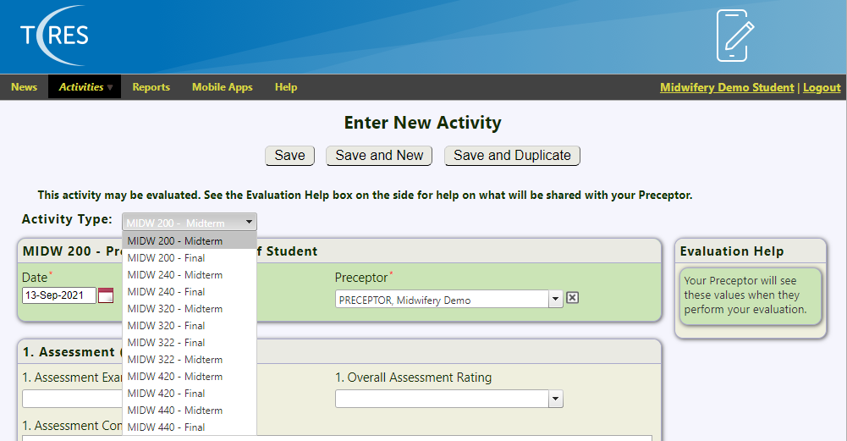

**Step 2:** Preceptor Evaluation of Student

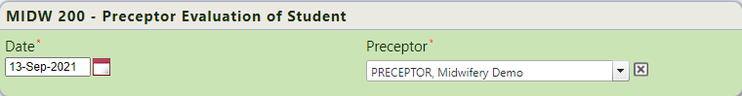

**Date:** Enter the date of the **Birth** not the date when the activity is being created in T-Res.

**Preceptor:** Select your Preceptors name from the drop-down menu or type the first few letters of their name to auto fill.

**Step 3:** Assessment (Self)

**Assessment Examples:** Multi-Pick list

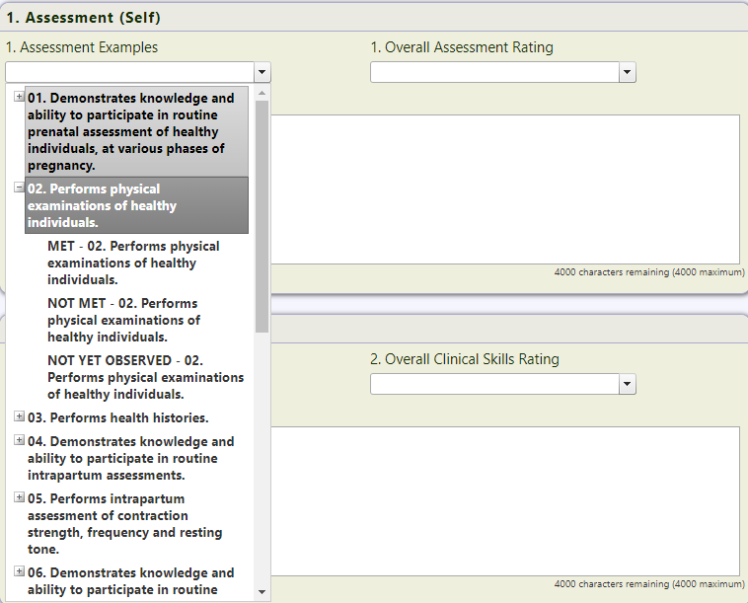

Select Met, Not Met or Not Yet Observed for all 14 of the list parents within the Assessment Examples Multi-Pick list.

**Overall Assessment Rating:** Single Pick List

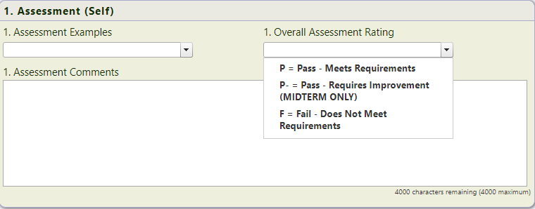

Choose the overall Assessment Rating that relates to the Assessment Examples

**Assessment Comments:**

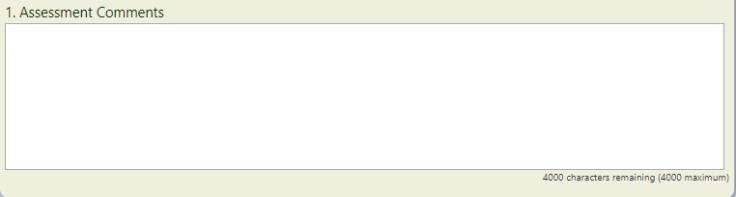

Add any Notes/Comments regarding the Assessment Ratings. These will be viewed by the Preceptor.

**Step 4:** Continue the same method for all 7 of the Self Evaluation sections

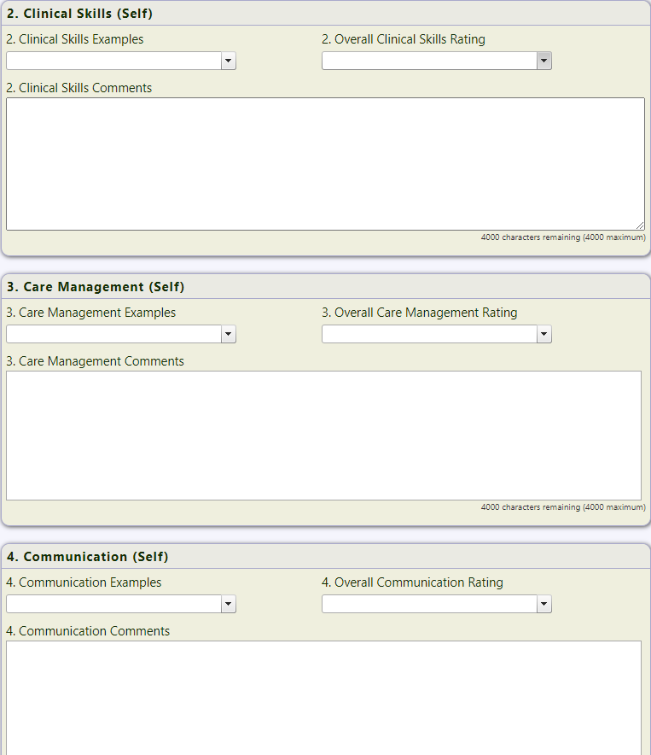

**Step 5:** Clinical Evaluation Summary

**Clinical Evaluation Summary:** Multi-Pick List

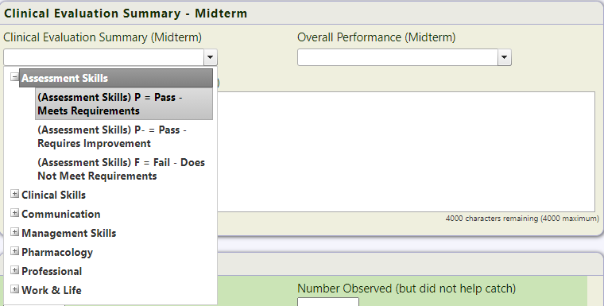

Choose the same Rating chosen from each of the 7 sections above.

**Overall Performance:** Single item pick list

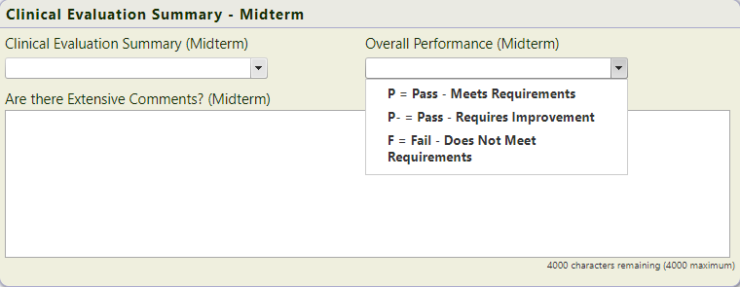

Choose the list item that summarizes the overall performance of the Midterm or Final

**Comments Section:**

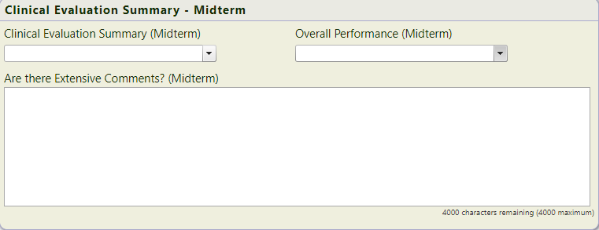

Add any comments related to the overall Performance of the Midterm or Final.

**Step 6:** Birth Numbers

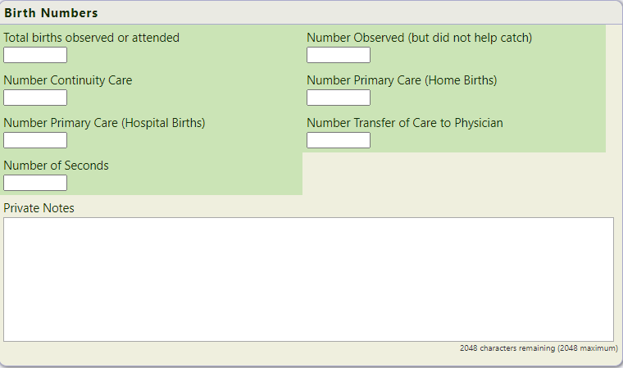

**Total births observed or attended:**

**Number Observed (but did not help catch):**

**Number Continuity Care:**

**Number Primary Care (Home Births):**

**Number Transfer of Care to Physician:**

**Number of Seconds:**

**Private Notes:** Private Notes section can only be viewed from your account, any information entered is for your eyes only.